**Stepper Motor Controller Rev. 0**

**Module Description**

Table of Contents

Introduction 2

Hardware 2

The Pro Micro 2

The A4988 Stepper Driver 2

The Power Supply 3

The Display 3

The Rotary Encoder 3

The Piezo Buzzer 3

Serial RS-232-Interface 4

Programming 4

Pin Configuration 4

Stepper Driver 4

The Piezo Buzzer 5

The LCD-Display 5

The Timer 1 Interrupt 6

The Interrupt Service Routine 7

The Rotary Encoder 8

RS-232 10

State Machine 13

Connector Pinouts 14

J1 - Power Connector 14

J2 – RS-232 Serial Interface 14

J3 – Rotary Encoder 15

J4, J5 – Stepper Motor Outputs 15

J6 – Reserved I/O-Pins 15

J7 – I²C/Display Connector 15

J8 – TX/RX Reserve Header 16

Jumpers 16

Assembly 17

The PCB 17

Cables 17

3D Printed Case 19

Revision History 22

Rev. 0 22

# Introduction

The Board is a multi-purpose stepper motor controller based on a Pro Micro (Arduino) and up to two (Allegro) A4988 stepper motor driver. The power supply of +12V (basic configuration) is provided via a barrel connector.

The user interface consists of an I²C display, a rotary encoded with integrated button switch and a piezo buzzer. The connectivity is either an RS232 serial interface or the USB serial interface of the Pro Micro.

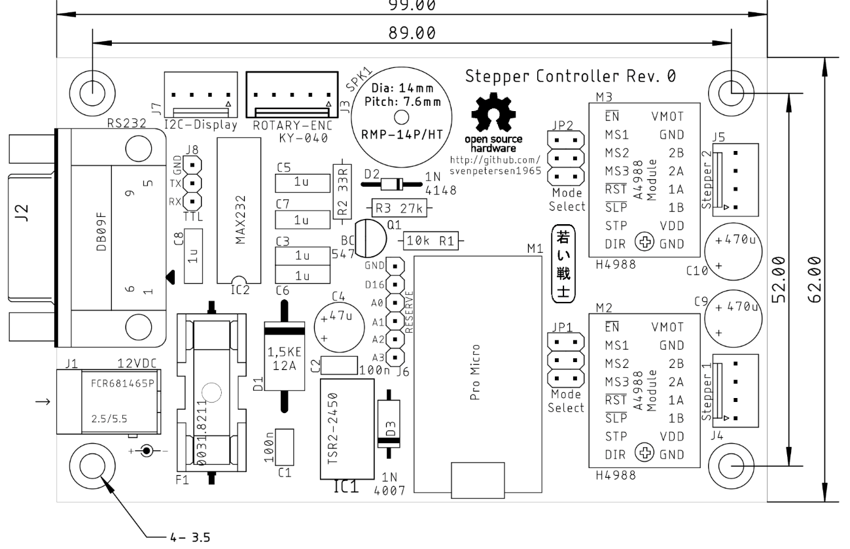

Figure 1: Dimensions of the Stepper Motor Controller

# Hardware

## The Pro Micro

The Pro Micro is an Arduino Leonardo (Software) compatible, Atmel ATmega32u4-based microprocessor module with 12 digital GPIO pins, 4 analog inputs (which can be used as digital I/Os as well), 32kB Flash, 2.5 kB RAM, 1kB EEPROM and a clock rate of 16MHz and a supply voltage of 5V (**3.3V** variants with 8MHz are available, but **not suitable** for this project).

## The A4988 Stepper Driver

The stepper drivers are widely available as modules from Ebay, AliExpress and other online shopping platforms (search term “A4988”). They are based on the Allegro A4988 chip. This chip has five (hardware) selectable step modes: full steps, 1/2, 1/4, 1/8 and 1/16 micro steps. The digital supply voltage is either 5V (used) or 3.3V, the stepper motor supply voltage is up to 35V (12V are used in this projects) and is capable to drive up to 2A.

The micro step mode is selected via jumpers (JP1 for Stepper 1/Channel A and JP2 for Stepper 2/Channel B).

The stepper drivers are controlled by three digital signals:

1. /EN: Enable, active low
2. STEP pulse input
3. DIR direction

The Enable signal /EN needs to be low to activate the driver. A HIGH level will deactivate the drivers. No current flows through the step motor windings, they can be moved freely, stepping will not be executed. The /EN signal of both stepper controllers are interconnected.

A HIGH pulse on the STEP input will result in one (micro) step of the motor in the direction determined by the DIR pin (HIGH = clockwise, LOW = counterclockwise).

Both, the STEP and the DIR signals are separate for each of the two stepper drivers.

There is a small potentiometer on each stepper driver module, which is for adjusting the motor current. To provide approximately equal micro steps, this potentiometer has to be adjusted properly. An adjustment based on the acoustic impression while the stepper motor is running is sufficient for most purposes. It also determines the “hold current”, which influences the supply current and the momentum, the stepper motor is capable to hold.

## The Power Supply

The power supply is connected to a 5mm/2.1mm barrel connector (+12V at the inner contact). The supply voltage is fused and over voltage protected, it is connected to the stepper motor supply pin (VMOT) of the stepper driver. Hence, it is possible to modify the PCB in a way, that 24V stepper motors can be driven. For this purpose, the fuse and the TVS diode D1 need to be modified.   
  
The 5V for supplying the Pro Micro, the digital side of the stepper driver, the display, the buzzer and the rotary encoder, is generated from the input supply voltage. For a +12V supply, a simple linear 7805 voltage regulator is sufficient. The PCB provides the space to install a DC/DC converter (Traco TSR2-2450) instead, that might be required for powering the PCB with a higher supply voltage.

## The Display

The display is connected to the I²C bus via a four-pin connector, which also provides a +5V pin for power supply. This will operate with the wide spread 16 columns/two lines or 20 columns/four lines LCD displays (I²C).

It is of course possible to connect an OLED-display with 5V supply voltage with a suitable software running on the Pro Micro.

## The Rotary Encoder

Rotary encoders with an integrated push button are usually pretty common and suitable for a menu-based mode selection and parameter entry. A widely available rotary encoder module (with on-board pull-up resistors) is the KX-040. The connector for the rotary encoder is adapted to this module. In case, a rotary encoder is not required for the supplication, the pins can be repurposed.

## The Piezo Buzzer

The purpose of the piezo buzzer is providing acoustic feedback or a warning signal for the user. Since piezo elements can produce some nasty voltage spikes when they get bent or beaten, the buzzer is not directly connected to the processor pin, but there is a protection circuit with a transistor and a diode.

## Serial RS-232-Interface

The Pro Micro provides a virtual serial interface via USB for communication and also a real serial interface with RX/TX pins. An RS-232 level driver is integrated on this board. The connector is the D-Sub 9, female, so the stepper controller is a DCE (Data Communication Equipment) like a modem. It connects to a computer (or other DTE = Data Terminal Equipment) via a 1:1 serial cable. Some feedbacks are provided (RTS-DTS and DTR-DRS-DCD).

# Programming

The Stepper Motor Controller (actually the Pro Micro) can be programmed with the Arduino IDE. The following chapters describe the source code of stepper_framework.ino, which does not do anything useful, except testing the hardware, nevertheless, this can be a framework to customized applications.

## Pin Configuration

The pin configuration looks like this:

|  |  |  |  |
| --- | --- | --- | --- |
| Pin | Direction | Signal | Purpose |
| D0 | out | TX | RS-232 Interface serial output |
| D1 | in | RX | RS-232 Interface serial input |
| D2 | - | SDA | I²C SDA signal |
| D3 | - | SCL | I²C SCL signal |
| D4 | in | ROT_SW | Rotary Encoder Switch |
| D5 | in | ROT_DATA | Rotary Encoder Data (actually output A) |
| D6 | out | STP_IN | Stepper driver 1 (Channel A) pulse input |
| D7 | out | STP_DIR | Stepper driver 1 (Channel A) direction input |
| D8 | input | ROT_CLK | Rotary Encoder Clock (actually output B) |
| D9 | out | SND_OUT | Output to the piezo buzzer |
| D10 | out |  | Stepper Enable (active low) for both stepper drivers |
| D14 | out | STP2_IN | Stepper driver 2 (Channel B) pulse input |
| D15 | out | STP2_DIR | Stepper driver 2 (Channel B) direction input |
| D16 | - | D16 | Reserved GPIO |
| A0 | - | A0 | Reserved (analog) GPIO |
| A1 | - | A1 | Reserved (analog) GPIO |
| A2 | - | A2 | Reserved (analog) GPIO |
| A3 | - | A3 | Reserved (analog) GPIO |

## Stepper Driver

The pins are defined like this:

#define step1 6 // stepper 1 step

#define dir1 7 // stepper 1 direction

#define step2 14 // stepper 2 step

#define dir2 15 // stepper 2 direction

#define nstpena 10 // enable both steppers (active low)

Pin initialization:

// setup stepper controller

digitalWrite( step1, LOW ); // LOW -> Step Signal

digitalWrite( dir1, st_direction ); // default direction

digitalWrite( step2, LOW ); // LOW -> Step Signal

digitalWrite( dir2, st_direction ); // default direction

digitalWrite( nstpena, HIGH ); // disable stepper by setting the enable pin HIGH

pinMode( step1, OUTPUT ); // step1 is an output

pinMode( dir1, OUTPUT ); // dir1 is an output

pinMode( step2, OUTPUT ); // step1 is an output

pinMode( dir2, OUTPUT ); // dir1 is an output

pinMode( nstpena, OUTPUT ); // nstpena is an output, that is the enable output for both stepper controllers

Previously, the direction was set to the desired value:

#define step_cw HIGH // for clockwise, the direction pin is HIGH

#define step_ccw LOW // for counterclockwise, the direction pin is LOW

*[…]*

digitalWrite( dir1, step_cw );

To switch on the stepper driver output and perform a step, the stepper drivers need to be enabled by setting the enable input LOW:

digitalWrite( nstpena, LOW ); // enable stepper controller

Setting the direction:

#define step_cw HIGH // for clockwise, the direction pin is HIGH

#define step_ccw LOW // for counterclockwise, the direction pin is LOW

*[…]*

digitalWrite( dir1, step_cw );

One step is performed like this:

void makeStepA( void ) { // make a step on motor A

digitalWrite( step1, HIGH );

delayMicroseconds( puls_width );

digitalWrite( step1, LOW );

}

## The Piezo Buzzer

Pin definition:

#define buzzer 9 // buzzer

Pin initialization:

pinMode( buzzer, OUTPUT ); // the buzzer is an output

Using the piezo buzzer:

// beep "hello"

tone( buzzer, 4000 ); // 1kz sound on buzzer

delay( 1000 ); // for 1 second

noTone( buzzer );

## The LCD-Display

The I²C LDC Display requires including two libraries:

#include <Wire.h> // import Wire library

#include <LiquidCrystal_I2C.h> // import LiquidCrystal_I2C library

The initialization includes the I²C address, the number of column and the number of lines. Here a 16x2 display is used.

LiquidCrystal_I2C lcd(0x27, 16, 2); // define the lcd display (i²c address

// 0x27, 16 columns, 2 lines

## The Timer 1 Interrupt

The Timer 1 interrupt is actually the heartbeat of the software. This interrupt occurs periodically and the so called ISR (Interrupt Service Routine) is executed. The cycle duration/periodicity depends on the setup (parameters) of Timer 1.

***Note:*** *Many beginners and intermediate programmers are afraid of using interrupts. This fear is actually not required! The ISR can be imagined as a sub routine, that is executed on interrupt, which is not noticed by the main program and can happen at any time. It is a task, that is executed in the background. The communication between the main program and the ISR is accomplished with variables.*

*There are two main rules for the Interrupt Service Routine:*

1. *Keep it simple (the execution times should not be too long)*
2. *The variables, which need to be seen by the main program and the ISR need to be declared as “volatile” to disable compiler optimizations, that might want to store such a variable in a register. The main program will look up the value by loading the register, while the ISR has changed the value in memory.*

*Rule number 2 is violated quite often, which leads to an unreliable/unpredictable processing of the events, that cause the interrupt.*

The declaration of a “volatile” variable looks like this:

volatile boolean step_flag = 0;

It works with all basic variable types. step_flag is set by the ISR (after a defines time has elapsed), the main loop is checking if step_flag is set, if so, a step is performed and step_flag is then reset by the main loop. That simple!

The setup of the timer interrupt looks like this:

/* ==================== TIMER 1 setup ======================= */

// Interrupt every 0.000496 sec (= 2016.13Hz)

// prescaler = 256

// Compare Match Register = 30

cli(); // disable interrupts

// reset timer1

TCCR1A = 0; // set TCCR1A register to 0

TCCR1B = 0; // set TCCR1B register to 0

TCNT1 = 0; // reset counter value

OCR1A = 30; // set compare match register of timer 1

TCCR1B |= (1 << CS12); // 1:256 pre-scaling for timer1

TCCR1B |= (1 << WGM12); // turn on CTC mode

TIMSK1 |= (1 << OCIE1A); // enable timer compare interrupt

sei(); // allow interrupts

The clock frequency is 16MHz for the Pro Micro (5V version). This frequency is divided by the prescaler (here 256). The result is a frequency of 62.5kHz, which is the input frequency of timer 1. The compare/match register is set to 30. So, timer 1 counts from 0 to 30 before the timer interrupt occurs. That are 31 counts.

CTC mode means the described cyclic counting mode.

The prescaler has a just few specific modes.

|  |  |  |  |
| --- | --- | --- | --- |
| CS12 | CS11 | CS10 | Prescaler |
| 0 | 0 | 1 | 1:1 (no prescaler) |
| 0 | 1 | 0 | 1:8 |
| 0 | 1 | 1 | 1:64 |
| 1 | 0 | 0 | 1:256 |
| 1 | 0 | 1 | 1:1024 |

A recommended reading about the timer interrupts is: <https://www.simsso.de/?type=arduino/timer-interrupts>

This website includes a parameter calculator.

## The Interrupt Service Routine

The ISR includes the timing for the steps and the processing of the rotary encoder signals.

ISR(TIMER1_COMPA_vect) { // function which will be called  
 // when an interrupt occurs at timer 1

// ========= every one second ========

if (++t1_ticks == t1_ticks_sec) { // set tick_1s every 2016 IRQ cycles (every 1 second)

tick_1s = 1;

t1_ticks = 0; // reset the tick counter

}

// === count the time before the next stepper step ===

if (++step_ticks == step_duration) {

step_flag = 1;

step_ticks = 0;

}

// ============== rotary encoder =====================

rot_read = digitalRead( rot_clk );

if ( rot_read != rot_clk_status) { // is rot_clk different for  
 // <debounce> cycles?

if (--rot_clk_debounce == 0) {

rot_clk_status = rot_read; // if yes: change status

}

}

else {

rot_clk_debounce = debounce; // if it is equal -> reset  
 // the debounce counter

}

if (rot_clk_status != rot_clk_status_old) { // did a status change  
 // occur?

if (rot_clk_status == LOW) { // is it a falling edge?

if (digitalRead( rot_data ) == LOW) { // yes: set the roraty value  
 //according to rot_data

rot_value--; // LOW -> CCW

}

else {

rot_value++; // HIGH -> CW

}

}

rot_clk_status_old = rot_clk_status; // update old status

}

rot_read = digitalRead( rot_sw ); // read rot switch

if ( rot_read != rot_sw_status) { // is rot_sw different for  
 // <debounce> cycles?

if (--rot_sw_debounce == 0) {

rot_sw_status = rot_read; // if yes: change status

}

}

else {

rot_sw_debounce = debounce; // if it is equal -> reset  
 // the debounce counter

}

if (rot_sw_status != rot_sw_status_old) { // did a status change  
 // occur?

if (rot_sw_status == LOW) { // is it a falling  
 // edge?

rot_button = true; // set switch semaphore

}

rot_sw_status_old = rot_sw_status; // update old status

}

}

The ISR consists of three parts:

1. A 1sec tick
2. A tick per desired (micro) step
3. The rotary encoder debouncing and processing (refer to the following chapter)

The 1sec tick is setting the “flag” tick_1s to 1. This flag can be monitored by the main loop. The main loop has to reset this flag after “detection”. This is called a “semaphore”, which means a structure, that is used for signaling between different processes (here it is the ISR and the main loop).

step_flag is the semaphore, which signalizes the main loop, that the time for the next set has elapsed. The main loop has to reset this flag after detection, as well.

## The Rotary Encoder

The rotary encoder part of the ISR (refer to the previous chapter) is supervising the “clock” and the “switch” signals.

The rotary encoded used here has mechanic contacts. Those are bouncing, when they change state. That means they are quickly oscillating for a while, before they finally settle. To detect a valid status change of the rotary encoder, the supervised signal has to stay the same for the debouncing period of time, which is determined be the constant debounce (a certain number of ISR cycles).

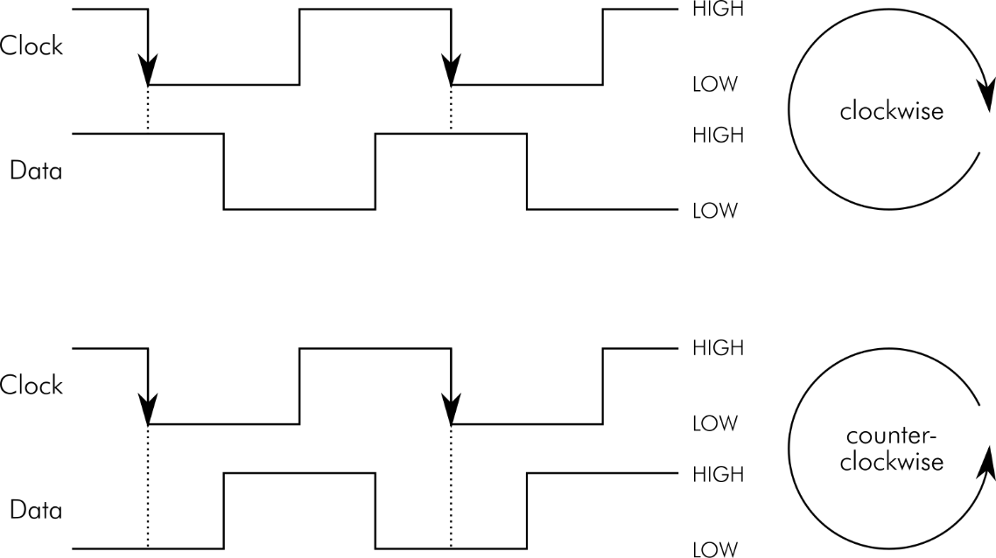

Figure 2: Operation of the rotary encoder

The relation between the clock and the data signal of the rotary encoder depends on the rotation direction. It is plus or minus a quarter period (that is +/- 90°, 360° is a complete period).

The direction can be detected by reading the data signal right after the falling edge of clock. This is accurate enough for a rotary encoder serving as an input device.

The interrupt service routine (ISR) is detecting a falling edge by comparing the recently read (valid) status of the clock signal (rot_clk_status) and the previously read status (rot_clk_status_old). In case both are different and the present status is LOW, a falling edge is detected. Now, the data signal is read. Depending on the state of the data signal, the variable, that holds the number of rotary encoder clicks (rot_value) is counted up (clockwise turn) or down (counterclockwise turn). rot_value is another semaphore, which is communicating the rotary encoder operation to the main loop.

The status of the rotary encoder’s push button is also monitored by the ISR. Like the clock signal, it has to be debounced. Since the button is a switch to ground (GND), a pushed button shows as reading a LOW state. The (after debouncing) valid state of the button is stored in the semaphore rot_button. The variable is true, if a button push is detected.

Processing the rotary encoder in the main loop is fairly simple. Just the previously mentioned semaphores have to be monitored.

Detecting the button:

lcd.setCursor(14,0);

if (rot_button==true) { // rotary encoder:   
 // button pushed

rot_button = false; // reset this flag

// after detection

Serial1.print("Button->set (Channel ");

if (stepper == step_cha) {

Serial1.println("A)");

}

else {

Serial1.println("B)");

}

}

Or the direction of rotation:

if (rot_value != 0) {

if (rot_value < 0) {

num_steps = num_steps - 10;

rot_value++;

}

else {

num_steps = num_steps + 10;

rot_value--;

}

lcd.setCursor(7,1);

lcd.print( num_steps );

lcd.print( " " );

Serial1.print( "Steps: " );

Serial1.println( num_steps );

}

Here the number of steps (num_steps) is reduced by 10 on each “click” while rot_value is < 0 (direction = CCW) and increased by 10 while rot_value is > 0 (direction = CW).

## RS-232

Other than the “regular” serial (via USB) interface, this RS-232 is addressed as ***Serial1*** in the Arduino IDE. The programming works like with the first serial interface. The recommended reading is <https://www.arduino.cc/reference/en/language/functions/communication/serial/>.

The initialization works with

Serial1.begin(9600);// the RS232 interface (RX, TX on pin 0 and 1) is

// Serial1.

This the 9600 bit/s (aka 9600 baud), 8N1 (8 data bits, No parity, 1 stop bit), a very common baud rate and data format.

Sending text via the serial interface is fairly simple:

Serial1.println( "Hello RS-232" ); // say hello

The RS-232 interface is also for receiving commands from a host. To collect this data and later process it (parsing the string = extracting the commands and parameters), some RAM space (a buffer) is allocated. For the parsing, the String functions are required

String recString = ""; // receive command buffer

[…]

recString.reserve(80);

A process, that is executed on every event on the Serial1 (RS-232) interface is

void serialEvent1() {

while (Serial1.available()) { // bytes available on Serial1?

recByte = (char)Serial1.read(); // read it

if (recByte == (char)10) { // is it "new line character"?

recComplete = true; // yes: the line is complete

}

else {

recString += recByte; // no: append character to input string

}

}

}

As long as there is data available on the interface, it is checked, if the data byte (actually a character) is a “Line Feed” (= (char)10 ). The line feed denotes the end of a command string. If so, a semaphore (recComplete) is set true. If it is a different character, this will be appended to the buffer recString.

The parsing of the received string in the main loop looks like this:

if (recComplete) { // a complete command line is received on RS-232

lcd.setCursor(0,1); // position the cursor on the second line

lcd.print( recString ); // print the received string

lcd.print( " " ); // clear the line after that string

recString.toUpperCase(); // convert the line to upper case

// (it is not case sensitive)

syntaxError = false; // reset the Syntax Error flag

if (recString[0] == 'A') { // is the first character an A?

stepper = step_cha; // yes: select Stepper#1 (channel A)

}

else if (recString[0] == 'B') { // is the first character a B?

stepper = step_chb; // yes: select Stepper#2 (channel B)

}

else {

syntaxError = true; // else, the syntax is not correct.

}

if (!syntaxError) { // syntax still correct?

int pos = (int) recString.indexOf(","); // find the first comma ","

if (pos < 1) { // if no comma is found

syntaxError = true; // set the Syntax Error Flag

}

else { // a comma is found:

recString.remove(0,pos+1); // remove the beginning, the comma

// included

num_steps = (int) recString.toInt();// convert the string to

// integer -> num_steps

if (num_steps<0) { // is it a negative number?

num_steps = -num_steps; // yes: make it positive

st_direction = step_ccw; // the direction is counterclockwise

}

else { // no:

st_direction = step_cw; // the direction is clockwise

}

digitalWrite( dir1, st_direction ); // set the direction of both

digitalWrite( dir2, st_direction ); // stepper motors

}

}

if (syntaxError) {

Serial1.println("? SYNTAX ERROR"); // report the syntax error

}

else {

Serial1.print("Execute: Channel "); // report the execution

switch (stepper) {

case step_cha: {

Serial1.print("A, "); // Channel A

break;

}

case step_chb: {

Serial1.print("B, "); // Channel B

break;

}

}

Serial1.print( num_steps ); // and the number of steps

if (st_direction == step_cw) {

Serial1.println(" steps, CW"); // and the direction

}

else {

Serial1.println(" steps, CCW");

}

}

recComplete = false; // reset the semaphore

recString = ""; // reset the recString (receive buffer)

The command line will let the selected stepper motor turn CW or CCW by the sent number of steps.

A proper command line looks like this:

<channel>, <number of steps>

While <channel> is A or B or a or b (it is not case sensitive) and a positive <number of steps> will turn the clockwise and a negative <number of steps> will turn counter clockwise.

## State Machine

The main loop is designed as a (finite-)state machine. This is a very common structure for micro controller software, which is quite useful to know.

Depending on the state, the actions and reactions are different. This (desired) behavior can be depicted in a state diagram (Figure 3).

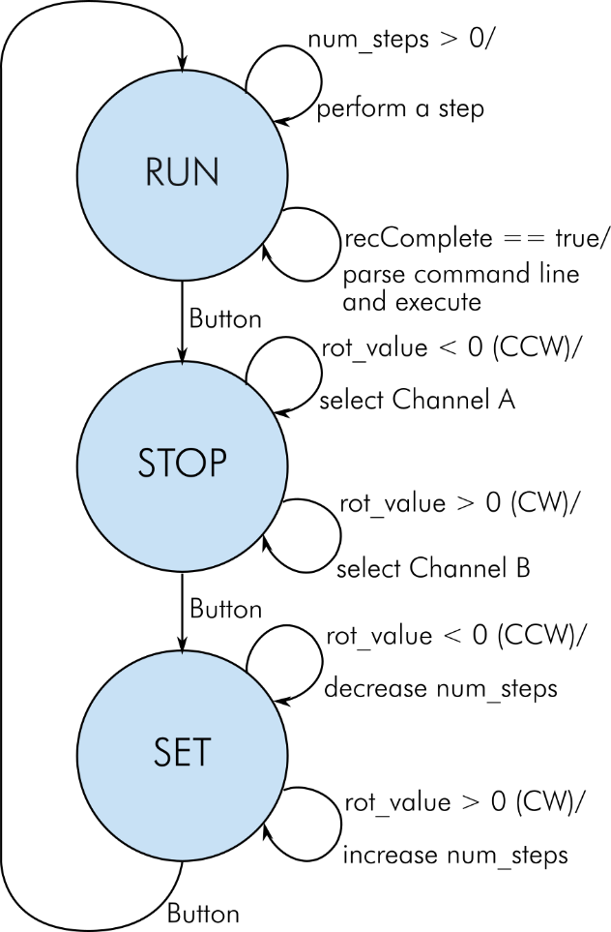

Figure 3: State diagram

The state machine has three states: RUN, STOP and SET. The states are represented by int values defined like this:

// state machine states

#define sm_stop // assigning a numbers to the state machine states

#define sm_set 1

#define sm_run 2

The state RUN is entered first, it checks, if num_steps is greater 0, if so, it performs a step and decreases num_steps by one.

Also, it checks, if a command line (via RS-232) is complete (recComplete is true), if so, the command line is parsed and executed.

In case the push button of the rotary encoder is pressed, it enters the state STOP.

The state STOP watches the rotary encoder. If it is turned counterclockwise, Stepper channel A is selected, if it is clockwise, Stepper channel B is selected.

If the push button is pushed, the state SET becomes active.

While SET the number of steps to perform next and the direction is adjusted. If the rotary encoder is turned clockwise, the variable num_steps is increased by 10, while counterclockwise, num_steps is increased by 10. A negative number will select counterclockwise for both stepper motors. Pressing the push button will enter the state RUN.

The over-all structure of the state machine is a switch/case construction in the main loop.

switch (state_machine) {

case sm_stop : {

[…]

break;

}

case sm_set : {

[…]

break;

}

case sm_run : {

[…]

break;

}

}

# Connector Pinouts

## J1 - Power Connector

J1 is a 2.5mm/5.5mm barrel jack.

|  |  |
| --- | --- |
| Pin | Signal |
| Inner | +12VDC |
| Outer | GND |

## J2 – RS-232 Serial Interface

D-Sub, 9 pins, female

|  |  |  |
| --- | --- | --- |
| Pin | Signal | Note |
| 1 | DCD | Feedback DCD – DTR - DSR |
| 2 | RxD | Output |
| 3 | TxD | Input |
| 4 | DTR | Feedback DCD – DTR – DSR |
| 5 | GND | Ground |
| 6 | DSR | Feedback DCD – DTR – DSR |
| 7 | RTS | Feedback RTS - CTS |
| 8 | CTS | Feedback RTS – CTS |
| 9 | RI | Not connected |

## J3 – Rotary Encoder

KF2510 series, 5pin (or Molex P/N 22272051) – vertical header with friction lock. Pinout for KY-040 rotary encoder module.

|  |  |  |
| --- | --- | --- |
| Pin | Signal | Note |
| 1 | GND |  |
| 2 | +5V |  |
| 3 | Switch | Button |
| 4 | Data | Actually, Channel A |
| 5 | Clock | Actually, Channel B |

The counterpart of J3 is a crimp housing (also KF2510 series, which is wide spread on Ebay, AliExpress and other online shops) and fitting crimp terminals. Alternatively, Molex P/N 22013047 and crimp terminal P/N 0850-0114 can be used.

## J4, J5 – Stepper Motor Outputs

KF2510 series, 4pin (or Molex P/N 22272041) – vertical header with friction lock or horizontal (90°) Molex P/N 22057048. J4 is Channel A/Stepper 1, J5 is Channel B/Stepper 2.

|  |  |  |
| --- | --- | --- |
| Pin | Signal | Note |
| 1 | 1B | stepper motor blue cable |
| 2 | 1A | stepper motor red cable |
| 3 | 2A | stepper motor green cable |
| 4 | 2B | stepper motor black cable |

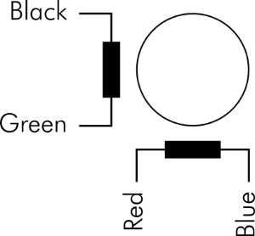

Figure 4: Windings of the stepper motor/cable colors

## J6 – Reserved I/O-Pins

The free GPIO-Pins of the Pro Micro are connected to a pin header (6 pins, 2.54mm pitch) which does not require to be placed. These pins might serve for connecting sensors/switches/actors

|  |  |  |
| --- | --- | --- |
| Pin | Signal | Note |
| 1 | GND |  |
| 2 | D16 | GPIO D16, PCINT2 |
| 3 | A0 | Analog input/GPIO |
| 4 | A1 | Analog input/GPIO |
| 5 | A2 | Analog input/GPIO |
| 6 | A3 | Analog input/GPIO |

## J7 – I²C/Display Connector

KF2510 series, 4pin (or Molex P/N 22272041) – vertical header with friction lock. Pinout for LCD Displays (16x2) with I²C controller.

|  |  |  |
| --- | --- | --- |
| Pin | Signal | Note |
| 1 | SCL | I²C clock |
| 2 | SDA | I²C data |
| 3 | +5V |  |
| 4 | GND |  |

The counterpart of J7 is a crimp housing (also KF2510 series, which is wide spread on Ebay, AliExpress and other online shops) and fitting crimp terminals. Alternatively, Molex P/N 22012041 and crimp terminal P/N 0850-0114 can be used.

## J8 – TX/RX Reserve Header

The TX and RX signals are routed to a pin header (3 pins, 2.54mm), which is not placed, in case it is desired to repurpose them or to watch the data exchange on the serial port/RS-232.

|  |  |  |
| --- | --- | --- |
| Pin | Signal | Note |
| 1 | GND |  |
| 2 | TX | serial output, GPIO D1 |
| 3 | RX | serial input, GPIO D2 |

# Jumpers

There are two jumpers, JP1 and JP2. Both serve the setting of the step modes (full step, ½ step, ¼ step, 1/8 step and 1/16 step). JP1 determines the mode of stepper #1/channel A, JP2 does so for stepper#2/channel B).

|  |  |  |  |
| --- | --- | --- | --- |
| MS1 / JPx 1-2 | MS2 / JPx 3-4 | MS3 / JPx 5-6 | Mode/micro step resolution |
| L/open | L/open | L/open | Full Step |
| H/set | L/open | L/open | Half Step |
| L/open | H/set | L/open | Quarter Step |
| H/set | H/set | L/open | Eighth Step |
| H/set | H/set | H/set | Sixteenth Step |

The footprints of the jumpers allow fix solder bridges instead of a pin header and jumper.

# Assembly

## The PCB

The PCB can be fully populated or some not requires parts can be omitted.

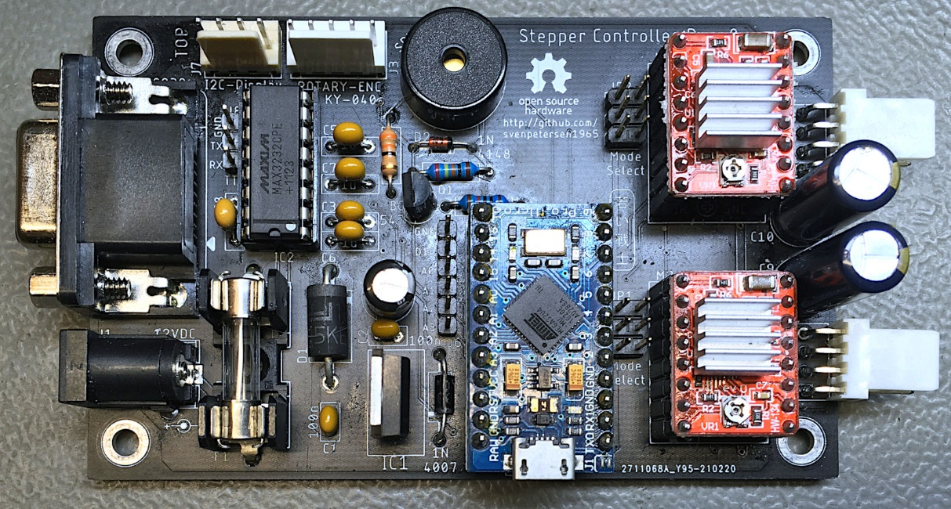

Figure 5: Fully populated PCB

|  |  |
| --- | --- |
| Requirement | Components |
| Always populate | J1, F1, C1, C2, C4, D3, M1, M2, C9, J4 |
| 2nd stepper controller | M3, C10, J5 |
| Buzzer | R1, R1, R2, R3, D2, SPK1 |
| Display | J7 |
| Rotary Encode | J3 |
| RS-232 | J2, IC2, C3, C5, C6, C7, C8 |
| Micro steps required and jumpered | Channel A: JP1, Channel B: JP2. A fix setting of the jumpers can be accomplished with solder bridges |
| Do not place (until required) | J6, J8 |

## Cables

In case the 90° pin headers are used for the stepper motor connection (J4, J5), there are only two cables required:

1. the display cable
2. the rotary encoder cable

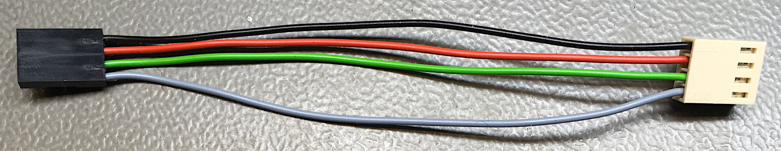

Figure 6: The display (I²C) cable

This display cable consists of the following components:

|  |  |  |
| --- | --- | --- |
| Pos. | Qty | Part |
| 1 | 1 | DuPont crimp housing, 4 pins |
| 2 | 4 | DuPont crimp terminals |
| 3 | 14cm | Cable, 0.25mm²/AWG24, black |
| 4 | 14cm | Cable, 0.25mm²/AWG24, red |
| 5 | 14cm | Cable, 0.25mm²/AWG24, green |
| 6 | 14cm | Cable, 0.25mm²/AWG24, grey |
| 7 | 4 | KF2510 crimp terminals |
| 8 | 1 | KF2510 crimp housing, 4 pins |

The colors of the cables are a suggestion only.

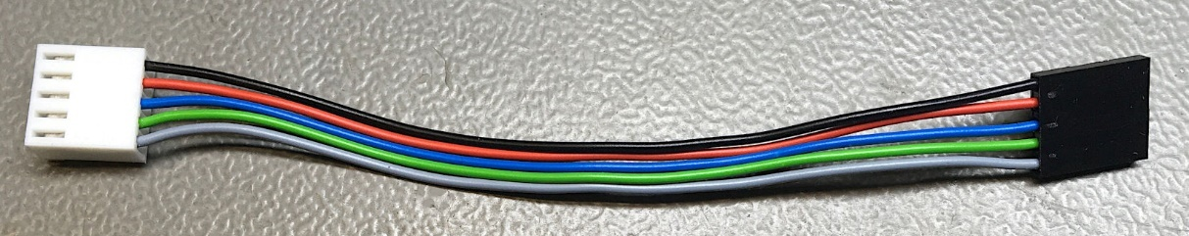

Figure 7: Rotary encoder cable

This rotary encoder cable consists of the following components:

|  |  |  |
| --- | --- | --- |
| Pos. | Qty | Part |
| 1 | 1 | DuPont crimp housing, 5 pins |
| 2 | 5 | DuPont crimp terminals |
| 3 | 14cm | Cable, 0.25mm²/AWG24, black |
| 4 | 14cm | Cable, 0.25mm²/AWG24, red |
| 5 | 14cm | Cable, 0.25mm²/AWG24, blue |
| 6 | 14cm | Cable, 0.25mm²/AWG24, green |
| 7 | 14cm | Cable, 0.25mm²/AWG24, grey |
| 8 | 5 | KF2510 crimp terminals |
| 9 | 1 | KF2510 crimp housing, 5 pins |

Optionally, a DIN connector can be used for the stepper motor connections.

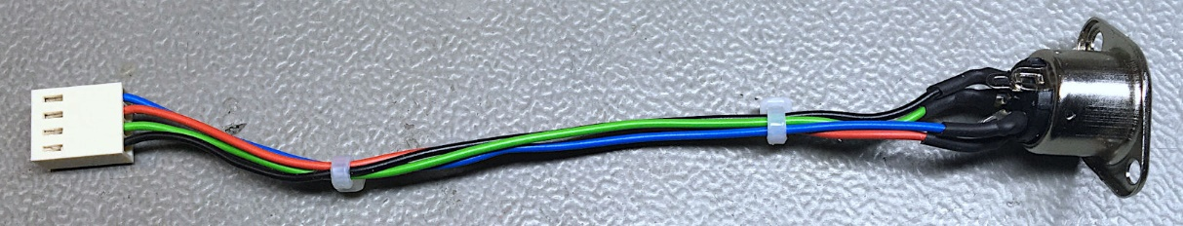

Figure 8: Stepper cable (internal, optional)

|  |  |  |
| --- | --- | --- |
| Pos. | Qty | Part |
| 1 | 1 | DIN Jack, 5 pins (e.g. Reichelt MAB 5S) |
| 2 | 14cm | Cable, 0.25mm²/AWG24, black |
| 3 | 14cm | Cable, 0.25mm²/AWG24, green |
| 4 | 14cm | Cable, 0.25mm²/AWG24, red |
| 5 | 14cm | Cable, 0.25mm²/AWG24, blue |
| 6 | 5 | KF2510 crimp terminals |
| 7 | 1 | KF2510 crimp housing, 5 pins |
| 8 | 6cm | Shrinkable sleeve (2.4/1.2) |

## 3D Printed Case

It is recommended to use the 3D printed case for this project. It consists of a top and a bottom shell and is constructed in Fusion 360. The STL files for 3D printing are provided as well as the Fusion 360 project.

The display is attached with 4 screws (C2.9x6.5 DIN 7981 recommended). The rotary encoder is attached with the nut included in it. The cables should be connected prior to mounting those components.

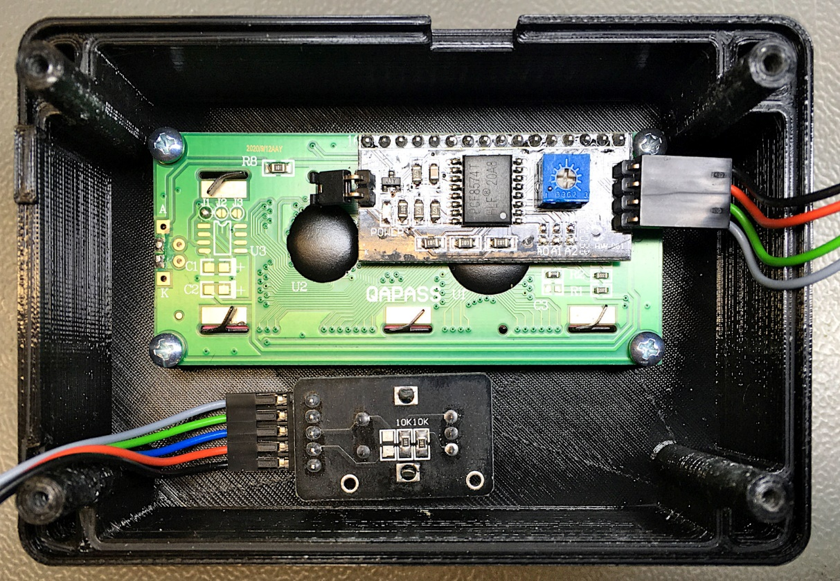

Figure 9: Top shell with mounted LCD display and rotary encoder KY-040

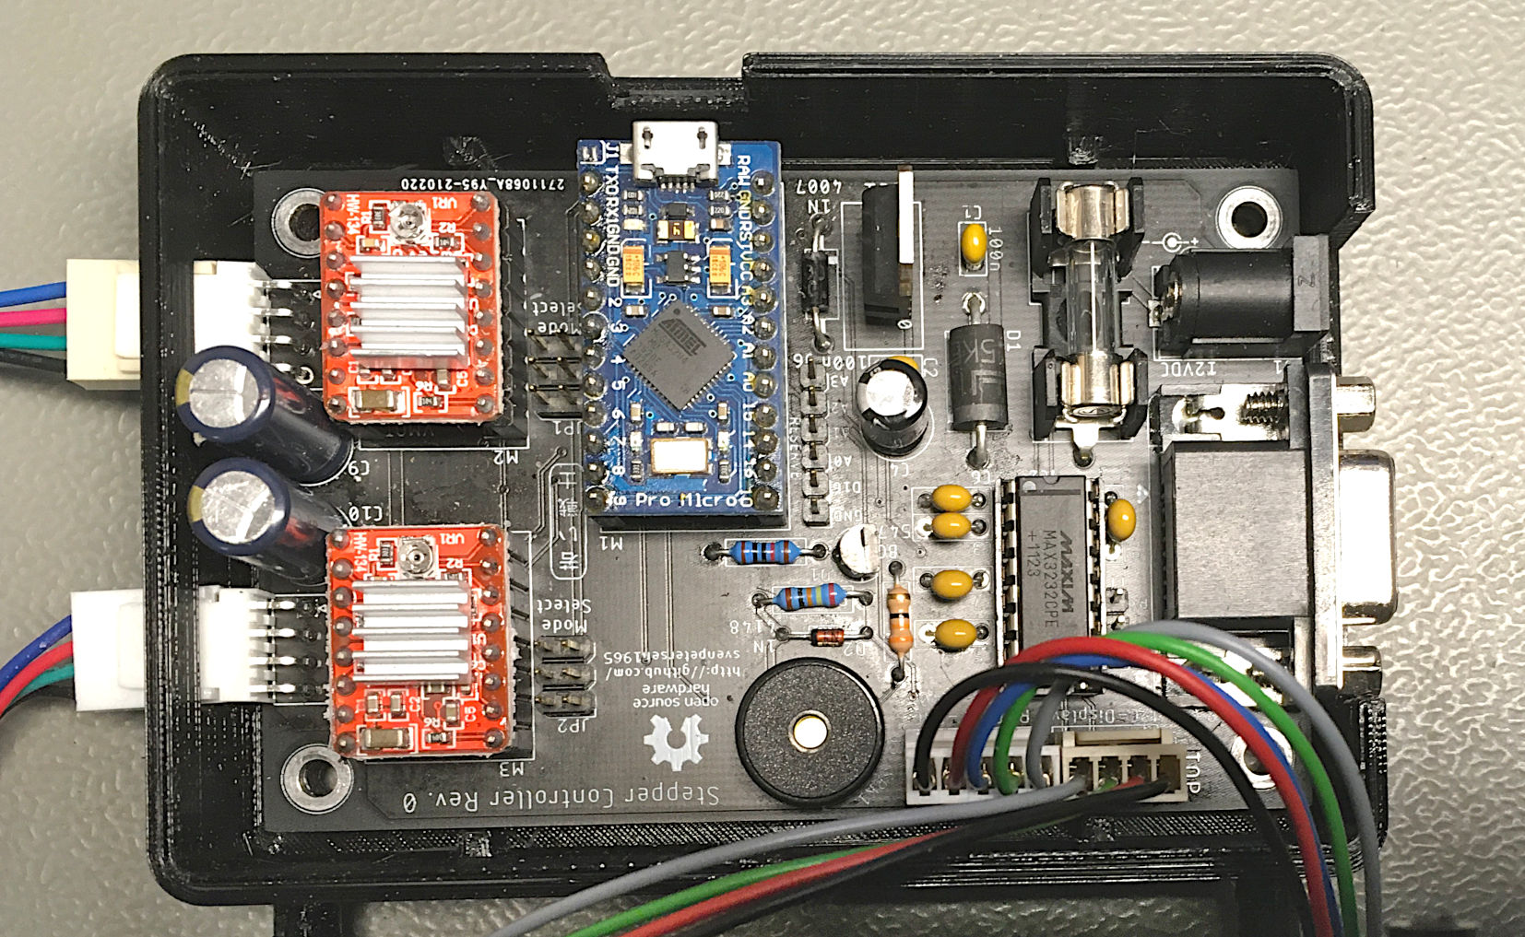

Figure 10: PCB in bottom shell

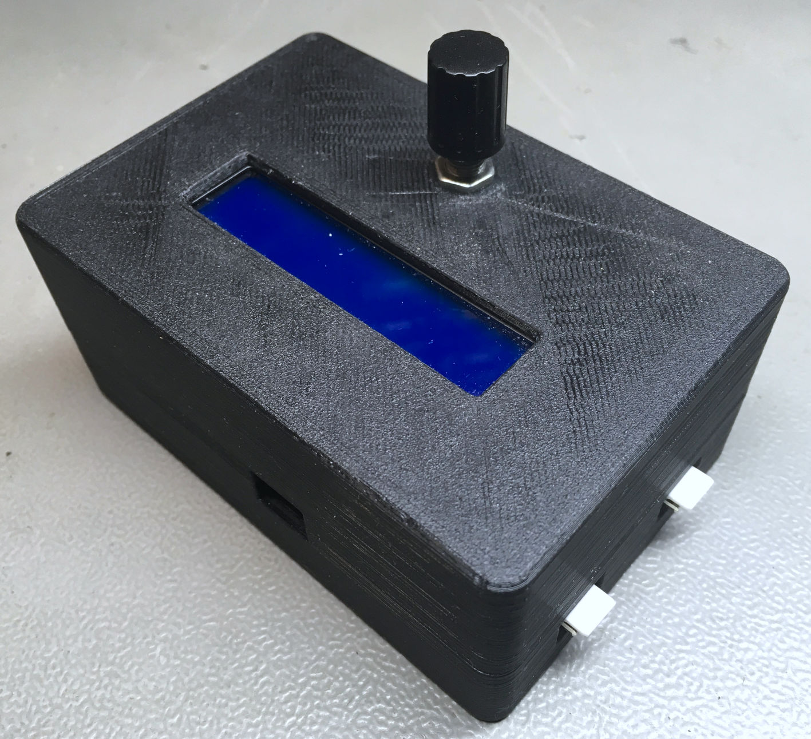

Figure : Case from top, left

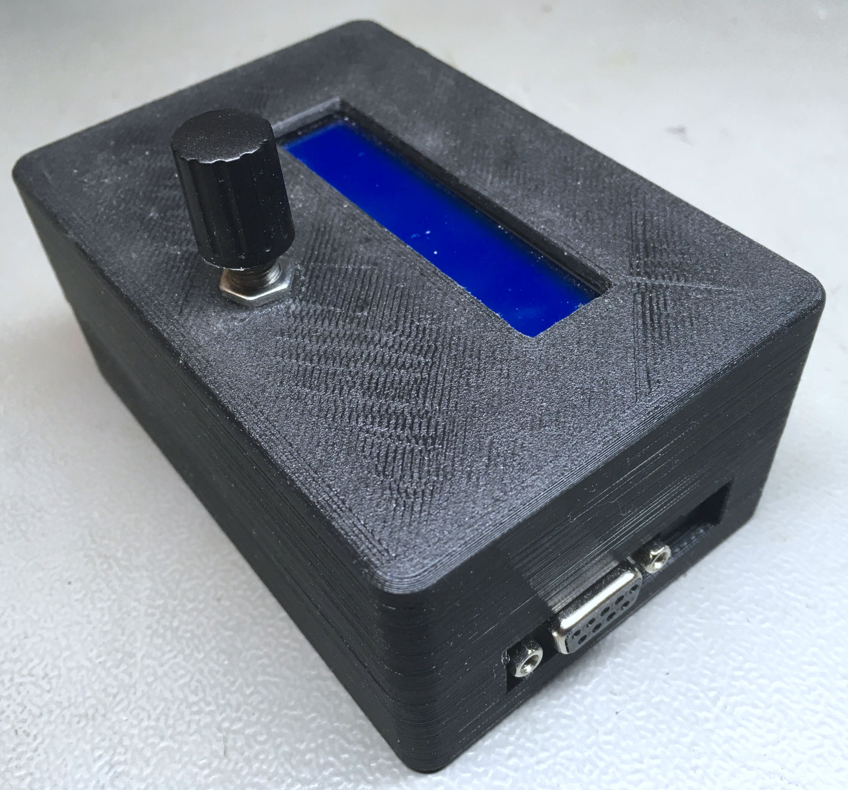

Figure : case from bottom, right

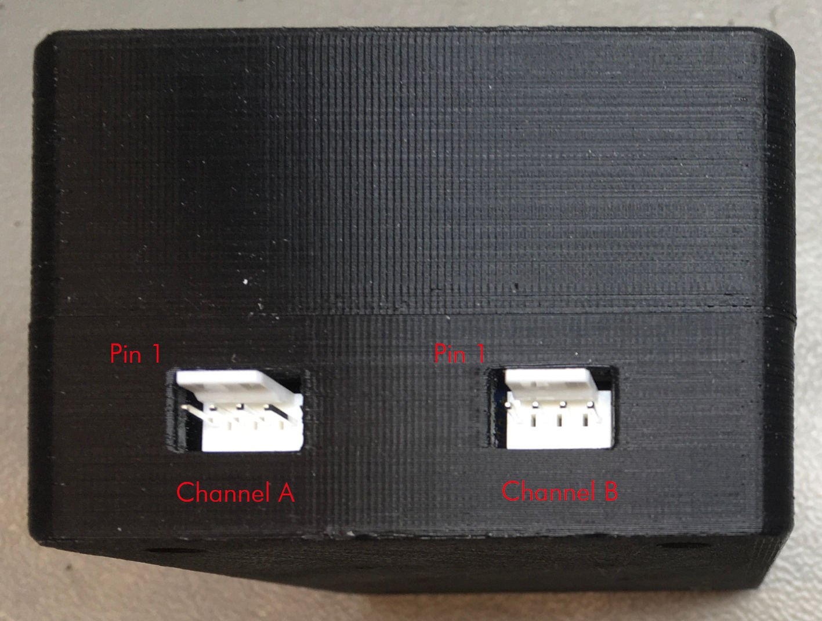

Figure : left side

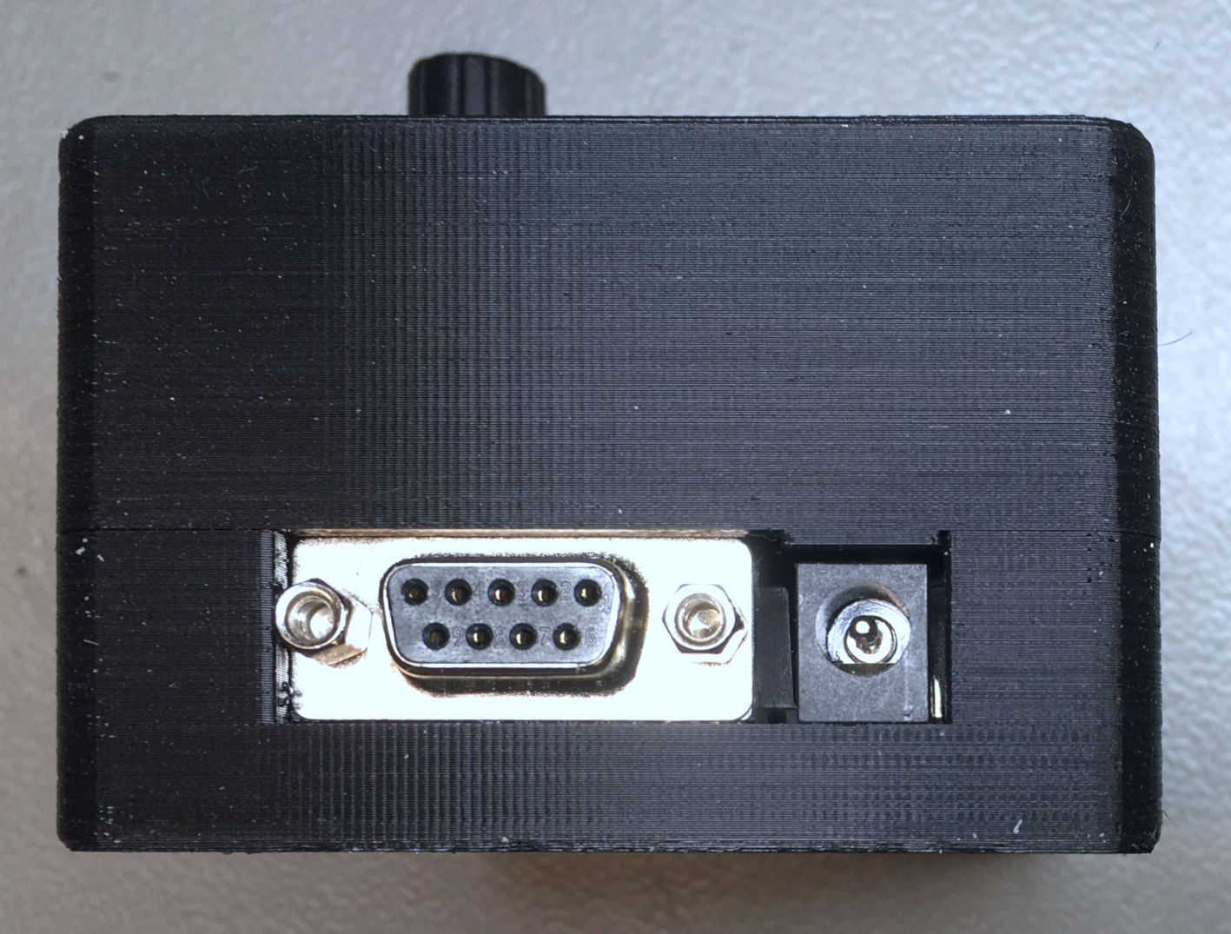

Figure : right side

There are different versions of the top and bottom shell provided. The top shell can have a mounting space for a DIN connector (that could serve as a stepper motor connector), the bottom shell can have the cut outs for the 90° stepper motor connector as shown in Figure 10.

For closing the case, with 4 screws (C2.9x13 DIN 7981 recommended) are required.

# Revision History

## Rev. 0

* Fully functional prototype